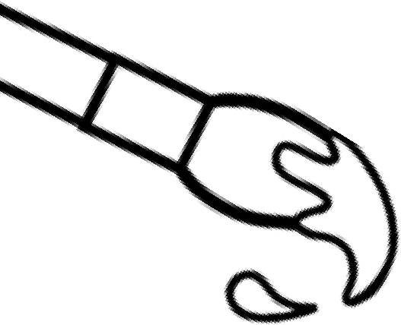
Welcome to River Trail Middle School
VISUAL ART
{2019-2020 Class Syllabus}
 | Mrs. Ricci Justis • Room #C111 • justisr@fultonschools.org • www.rivertrailart.weebly.com
 | This 9-week course is filled with projects and activities that will boost your critical thinking habits, improve your collaborative participation, grow your creativity and develop your communication skills through writing and talking about art. We will focus our exploration of the art world through the Studio Habits.
In this class you will…  - Generate and conceptualize artistic ideas and work.  - Organize and develop artistic ideas and work.  - Refine and complete artistic work.  - Analyze, interpret, and select artistic work for presentation.  - Develop and refine artistic work for presentation.  - Convey meaning through the presentation of artistic work.  - Perceive and analyze artistic work.  - Interpret intent and meaning in artistic work.  - Apply criteria to evaluate artistic work.  - Synthesize and relate knowledge and personal experiences to make art.  - Relate artistic ideas and works with societal, cultural and historical context to deepen understanding.  (National Core Art Anchor Standards) |  | Materials needed daily:  - A pencil  - Your Surface  - Sketchbook Due:_______  - Pocket folder Due: ______  - Growth mindset
Grading:
Each studio project/unit has a Rubric used for student self-assessment as well as instructor assessment. Grading scale will follow FCS district grading policy (details on back).

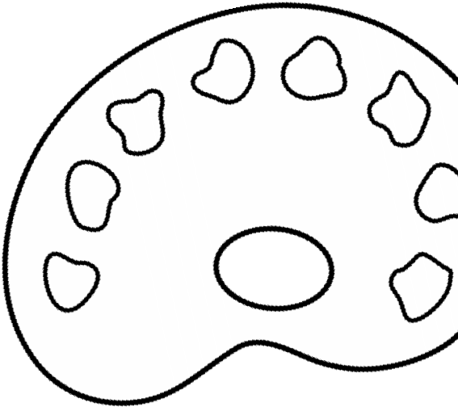
The majority of our work will be assessed using the Studio Habits of Mind:
- Develop Craft
- Engage & Persist
- Envision
- Express
- Observe
- Reflect
- Stretch & Explore
- Understand Art World

Hetland L., Winner, E., Veenam S., Sheridan, K. (2013) Studio Thinking 2: The Real
Benefits of a Visual Arts Education, NY: Teachers College Press
Class assignments:
Studio projects • Daily class Warm UPS
Collaborative projects • Sketchbook Assignments • Class Assignments
Student expectations in the art room:  Respect, Responsibility & Risk Taking! |  | A little something about your teacher:  Mrs. Justis grew up in Woodstock, GA and received her Art Education degree from GSU and a Master's of Arts Education from UF. She has been making art her whole life, has been teaching 15 years, and is married to James, has one step-son (Asa), one son (Jesse), and one Fur Kid, Fred  (who has a cute under bite).
RTMS Art grading scale based on Fulton County requirements
A-90 and above B-80-89 C-70-79 F-below 70
-60% Studio Activities (Summative)
-40% Class work, quizzes, written assignments, daily activities (Formative)
*Please note, students’ overall grade average will not be affected by an assignment until the due date. If a student turns in an assignment early, the parent will be able to view the score, but the overall grade in the class will not change calculation until the due date assigned.
*“All students are expected to exemplify academic honesty. “Academic Honesty’ means performing all academic work without plagiarism, cheating, lying, tampering, stealing, giving or receiving unauthorized assistance from any other person, or using any source of information that is not common knowledge without properly acknowledging the source.” SEE student handbook.
*Make-up Work*Incomplete Work*Grade Recovery
-Incomplete work will receive a grade of 70.
-Students are responsible for making up all work that they miss when they are absent. Please discuss options with Ms. Justis.
-A student who has a low (73 or below) or failing cumulative grade may ask the teacher for opportunities to improve his/her grade when all work required to date has been completed and the student has demonstrated a legitimate effort to meet all course requirements, including attendance.
*Open Studio* After talking with Ms. Justis, students who desire additional time to make up work or complete work may attend open studio.
*Discipline for Individuals
Minor (in this order): Students who choose to make minor infractions will receive a respectful verbal warning, refocus table time, written reflection on goals/behaviors essay assignment, and parent contact.
Major: Such as-disruptive behavior, destruction of property, bodily harm or disrespect will result in immediate referral to an administrator or an immediate detention. *Students who misbehave under substitute supervision will receive immediate consequences to be determined by administration.
*TARDY POLICY; Please become very familiar with the policy outlines below.
Art is a 9 week class that goes quickly and each moment counts, therefore there is a STRICT TARDY POLICY.
- All students are made aware of tardy policy and daily encouraged and celebrated for timeliness.
- A student’s first tardy initiates a verbal warning and reminder of value of being timely.
- A student’s second tardy initiates an email alert home in hopes of creating a resolution.
- A student’s third tardy initiates a detention.
- Detention times will be held in the morning before school starts, date to be determined.
- Students with a pass are not considered late. If a student comes in repeatedly with a pass this is looked into.
Printed Student First & Last Name _____________________________________Date_______
Parent/Guardian Signature ____________________________________________Date_______
Signed Syllabus Due____________________ Sketchbook Due________________

For more information about Sketchbooks visit the main page of class website!

